My English Hub

# 📘 My English Hub

### Inglés B1 – Expresate con soltura y ampliá tus conversaciones

### 👋 You are welcome here!

En este nivel vas a empezar a mantener conversaciones más largas, compartir ideas, contar experiencias pasadas y hablar de planes. Este material te ayudará a ganar fluidez, ampliar tu vocabulario y expresarte con más seguridad.

## 🕰️ Simple past

### 🔹 We talk about events in the past

* I went to the beach
* Last week / Two years ago / In 2020
* It was amazing / boring / exciting
* We had a great time

### ▶️ Simple Past Tense - English For Yourself

### 🔸 Dialogue

👤 A: Did you go out last weekend?  
👤 B: Yes! I visited my cousins in the countryside.  
👤 A: Sounds fun! What did you do?  
👤 B: We went hiking and had a barbecue.

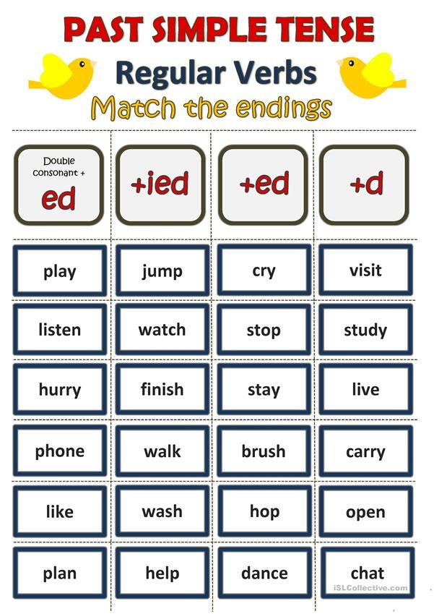

**Complete the sentences with the past simple of the verbs in brackets.**

1. Yesterday, I __________ a funny movie on TV. (watch)
2. We __________ the door before leaving. (open)
3. My sister __________ me with my homework. (help)
4. They __________ in the park for an hour. (walk)
5. She __________ to music all afternoon. (listen)
6. I __________ my hands before dinner. (wash)
7. He __________ his friend on the phone. (phone)
8. We __________ in the school talent show. (dance)
9. Tom __________ his bag and went to school. (carry)
10. I __________ “hello” when I saw her. (chat)

## **Change these sentences into their negative form:**

1. She visited her grandmother last weekend.
   1. She didn't visit her grandmother last weekend.
2. We stayed at a nice hotel by the beach.
3. He cried during the sad movie.
4. I studied English for two hours yesterday.
5. They planned the trip together.

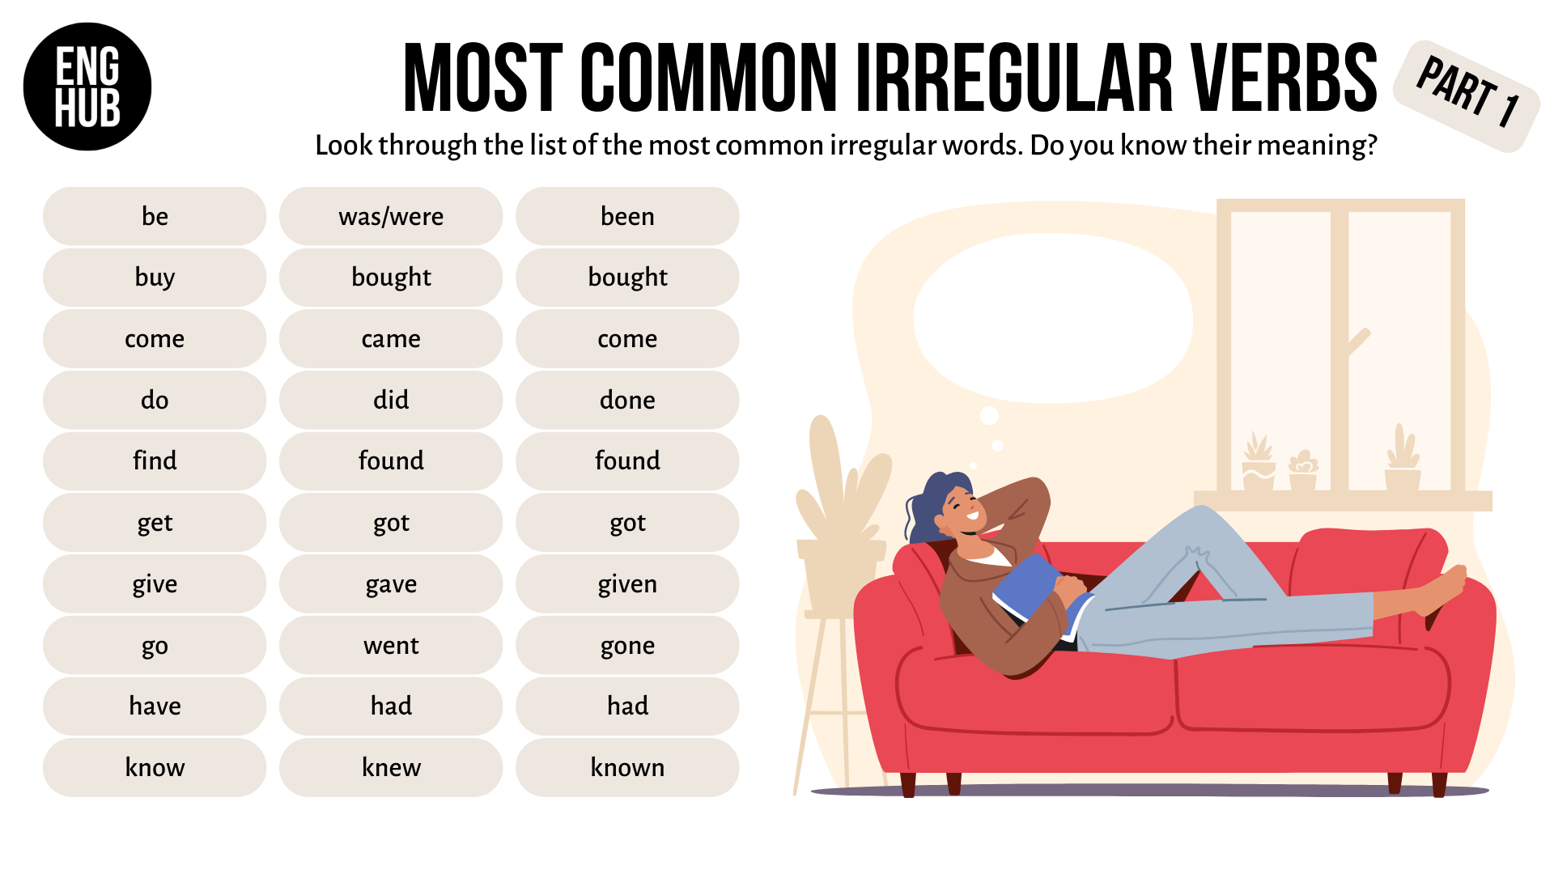

**Complete the sentences with the past form of the verbs in brackets.**

1. I __________ a new phone last week. (buy)
2. She __________ to the office early this morning. (go)
3. We __________ a delicious cake for her birthday. (make)
4. They __________ all the answers in the test. (know)
5. He __________ me a very nice gift. (give)
6. The cat __________ under the sofa. (come)
7. My parents __________ very happy about the news. (be)
8. We __________ a great time at the party. (have)
9. She __________ the money and ran. (take)
10. I __________ a beautiful painting at the gallery. (see)

And now, here are **5 affirmative sentences** to be turned into **negative**:

1. She gave me a book for my birthday.
   1. She didn't give me a book for my birthday.
2. We saw a shooting star last night.
3. He had a big breakfast.
4. I went to Paris last summer.
5. They knew the answer.

## 🎧 Interactive Activities

1. [List of Regular and Irregular verbs](https://www.liveworksheets.com/w/en/english-second-language-esl/562456)
2. [Use past tense in sentences](https://www.liveworksheets.com/es/w/en/english-second-language-esl/1929743)
3. [Past Simple Listening Comprehension](https://www.liveworksheets.com/w/en/english-second-language-esl/1070912)

## ✅ Mini Test

1. “I ___ to the beach last weekend.”  
   a) go  
   b) went   
   c) going
2. “I ___ a movie yesterday.”  
   a) watching  
   b) to watch   
   c) watched
3. “This book _____very interesting, I read it last year.”  
   a) is  
   b) was   
   c) to be

## 📲 ¿Querés seguir mejorando tu inglés?

👉 Consultá por el nivel B2  
👉 Escribinos por WhatsApp para practicar con nosotros  
👉 ¡My English Hub te acompaña paso a paso!